Entering an Home and Community Based Services Waiver (HCBS) incident into NIMRS

After login, several screen containing updated system and application messages will be seen.
To close this message screen click the ‘continue’ button or the right hand corner ‘X’

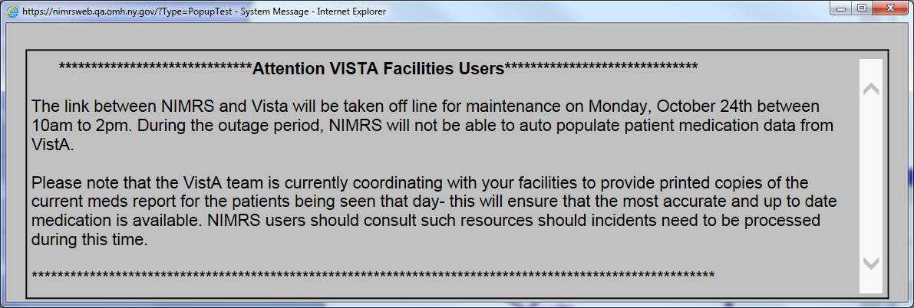

To enter a new incident click New Incident on the side menu.
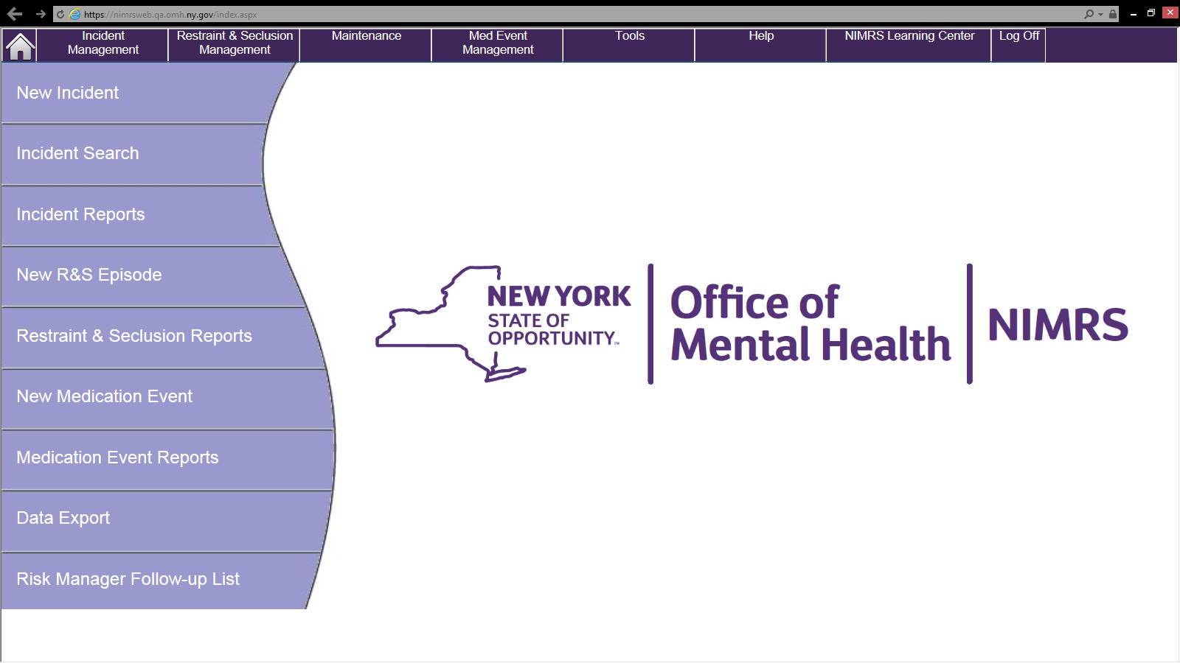

Another pop up appears which only applies to programs which are under the auspice of the Justice Center.
This window can be closed by hitting the red X in the upper right hand corner.

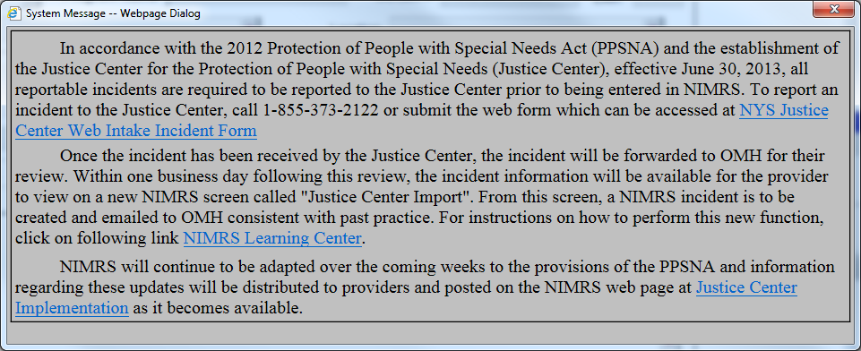

Select the ward/program (001 Home and Community Based Waiver) first. Be certain a HCBS program is selected. The way NIMRS functions and what it requires you to fill out & report depends on the ward/program that is chosen. The ward/program cannot be changed after saving.
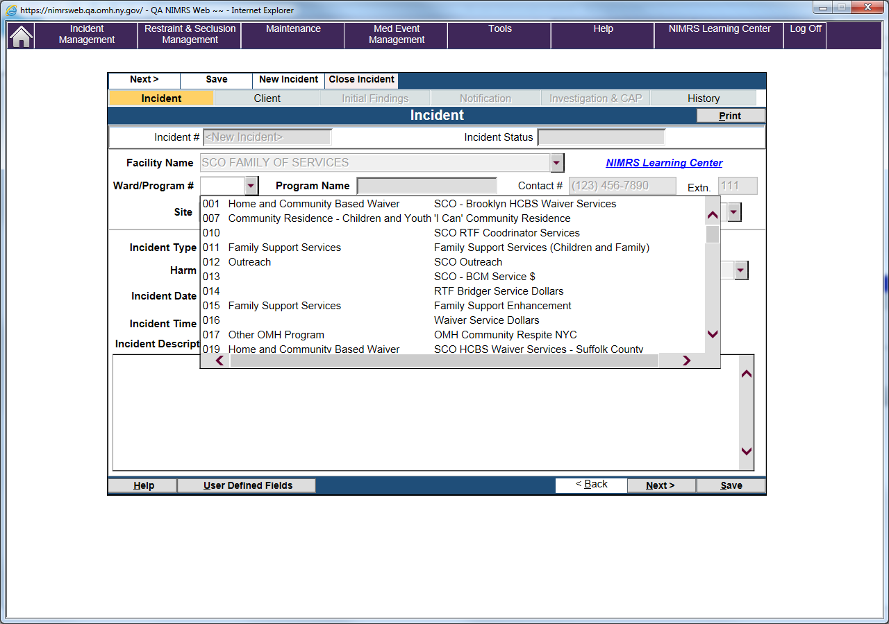
Fill in each field. Click the ‘Next’ button to proceed to the next page. Save the incident by clicking the ‘Save’ button. 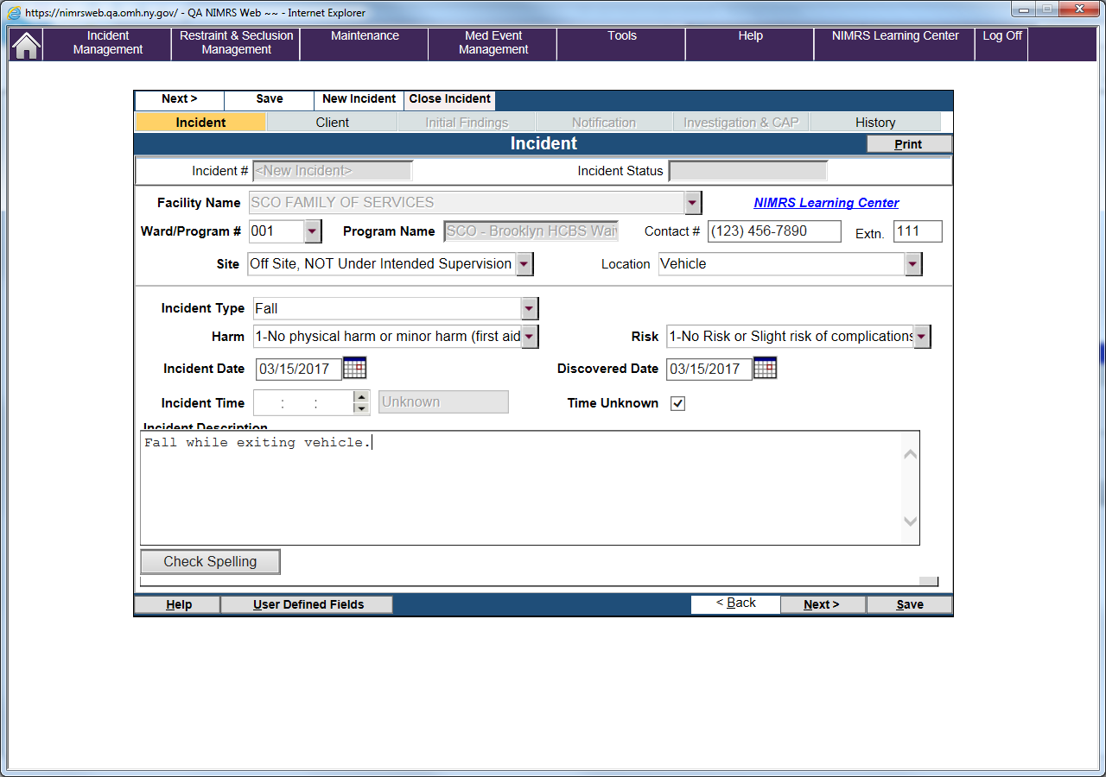
Note that the incident # appears after pressing the Save button.
The client tab will present a ‘client search’ pop up. Simply enter a few letters of the client’s first and last name and hit search.
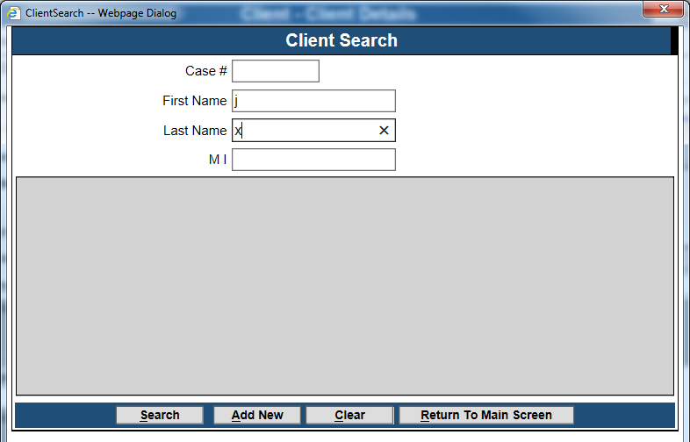

If he or she is found in the NIMRS data base the name will appear as a row. Double click the row and all of the demographic data for the client will populate the client tab. If the client is not found enter the first and last names and press the ‘add new’ button.
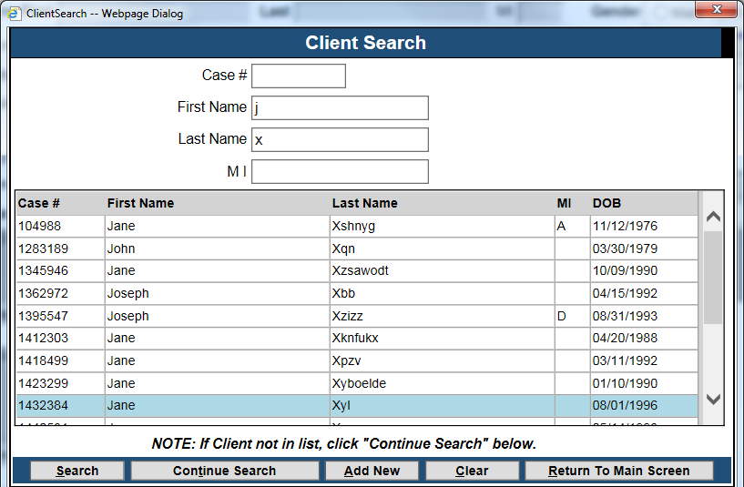
6

Click Yes in the Home and Community Based Services field.
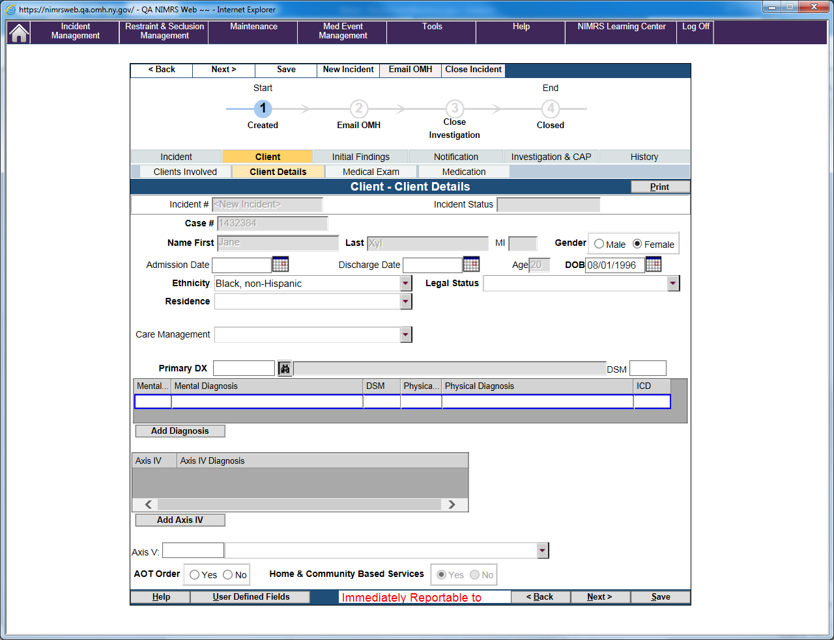

Continue filling out the incident report as completely as possible, saving after every 1 or 2 screens. NIMRS pop up messages will inform you if there are errors.
Once all of the information is completed on the form hit the ‘Email OMH’ button. This will send an email to the HCBS Waiver Unit in Central Office to notify them of the incident.
If you have any questions, please contact the HCBS Waiver Team at the following email address: dcfs@omh.ny.gov.

